Ex. No.: 3 Date: 16-02-2022

**Problem statement:**

Write programs in Java to create three-tier applications using JSP and Databases

1. for conducting on-line examination.

2. for displaying student mark list. Assume that student information is available in database which has been stored in a database server.

I. Procedure for creating design of client and server program

1. Design the HTML page (Exam_Client.html) with the following

i) Create a form to get the input from the user.

ii) Use radio buttons to make various options for the questions.

iii) Set the URL of the server (Exam_Server.jsp) as the value of the action attribute.

iv) Use submit button to invoke the server and send the form data to the server.

2. Create the JSP file with the following

i) Read the input from the client.

ii) Retrieve the answers from the database.

iii) Match the answers from the user with the correct answers from the database table.

iv) For each correct answer increment the mark by 1.

v) Server displays the mark and result to the client as a response.

II. Form Design

Step 1: Create a database in MS-Access or MySQL. For instance, you have to create a student database (min 15 students) in MS-Access or MySQL. Inside this database create a table with following fields.

Step 2: Write a JSP document as following form format with style CSS format to conduct online exam and Validation (The form validation is also done in above JSP script)

Step3: After inputting the data appropriately, Click the finish button. And a Mark sheet will be displayed with style CSS format as follows and also update the table in database.

Design: (Block diagram)

**Tool used:**

* Apache Tomcat
* NetBeans IDE
* Java JDK
* MySQL
* JSP
* HTML
* CSS
* Javascript

Code:

Form:

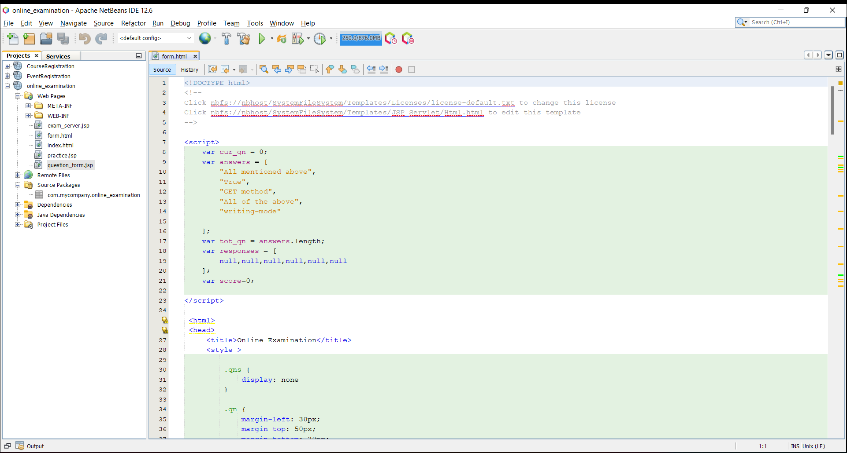

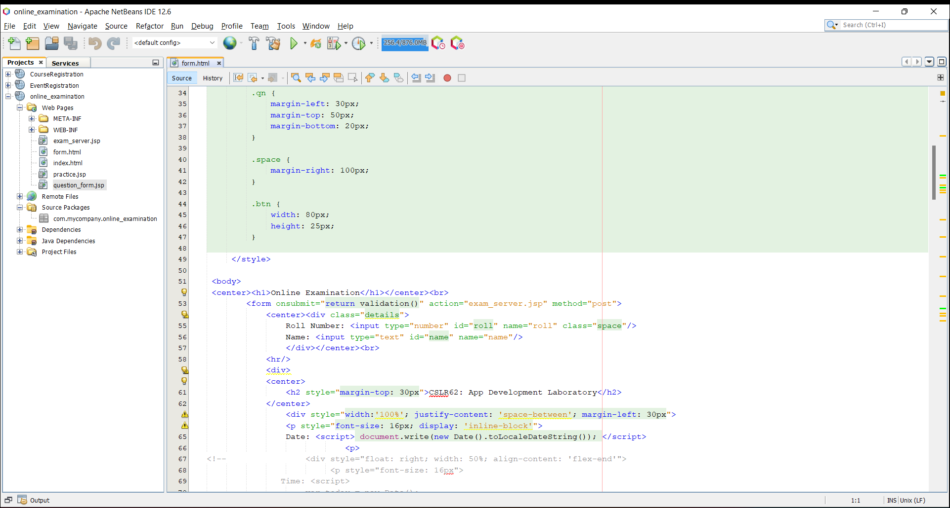

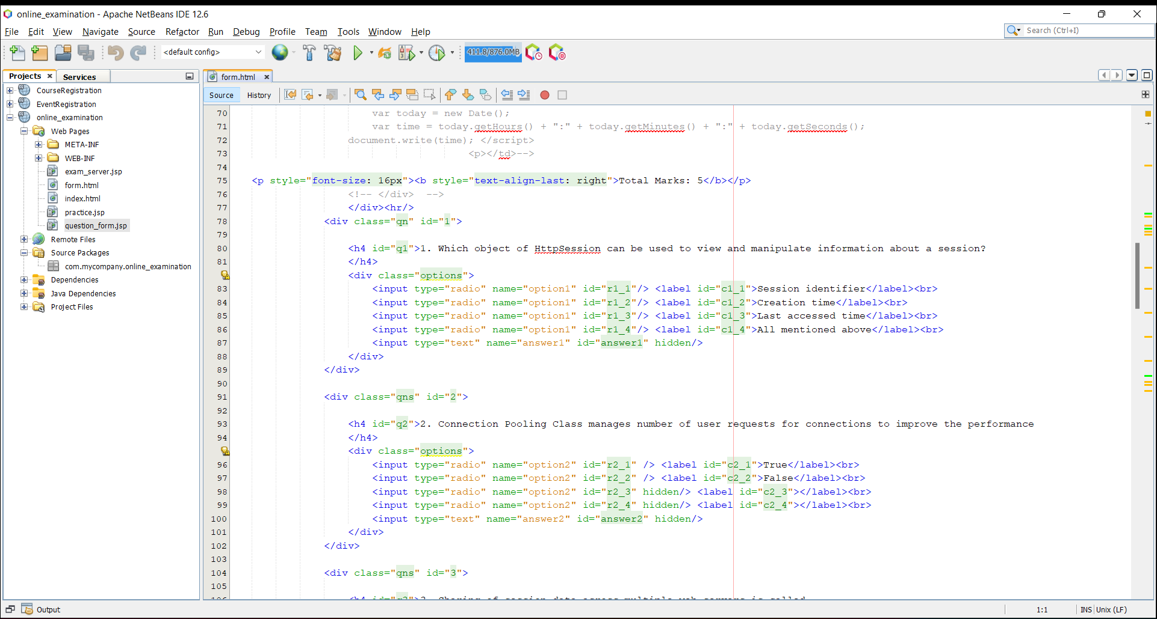

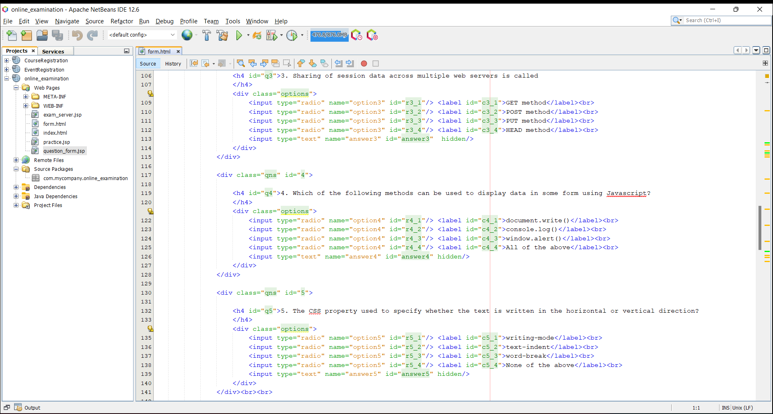

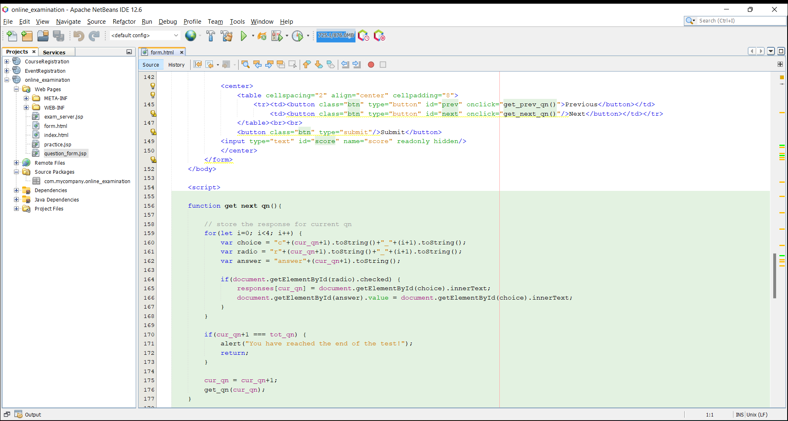

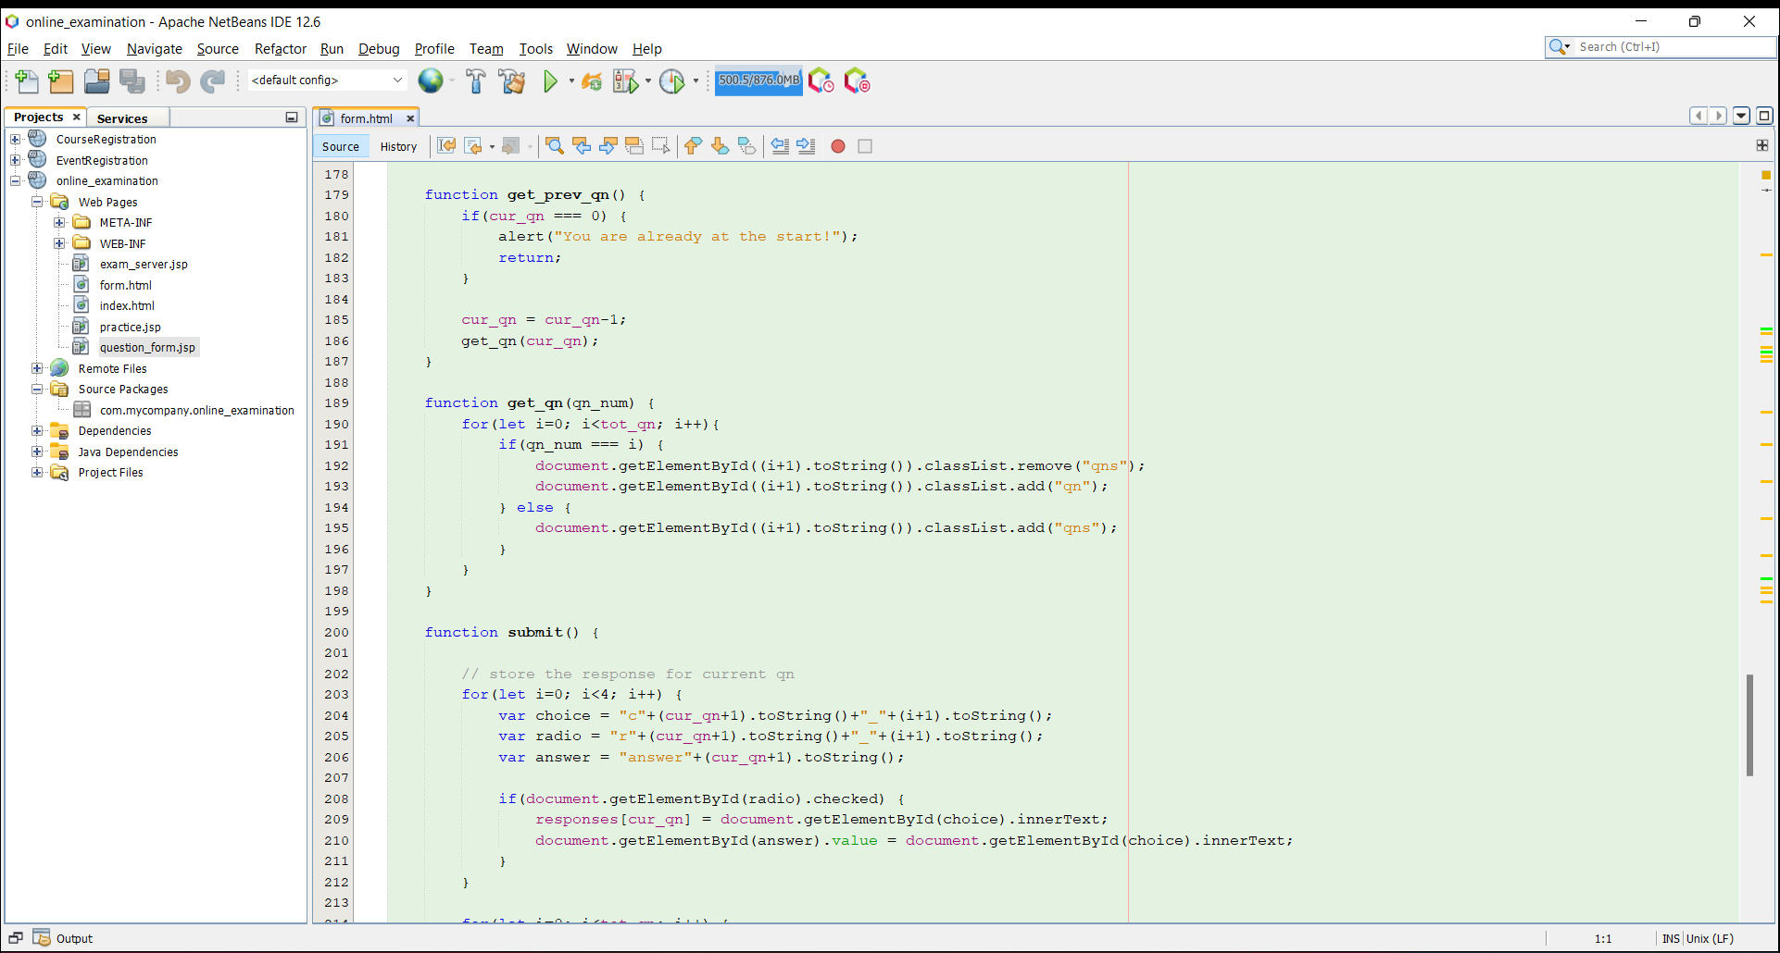

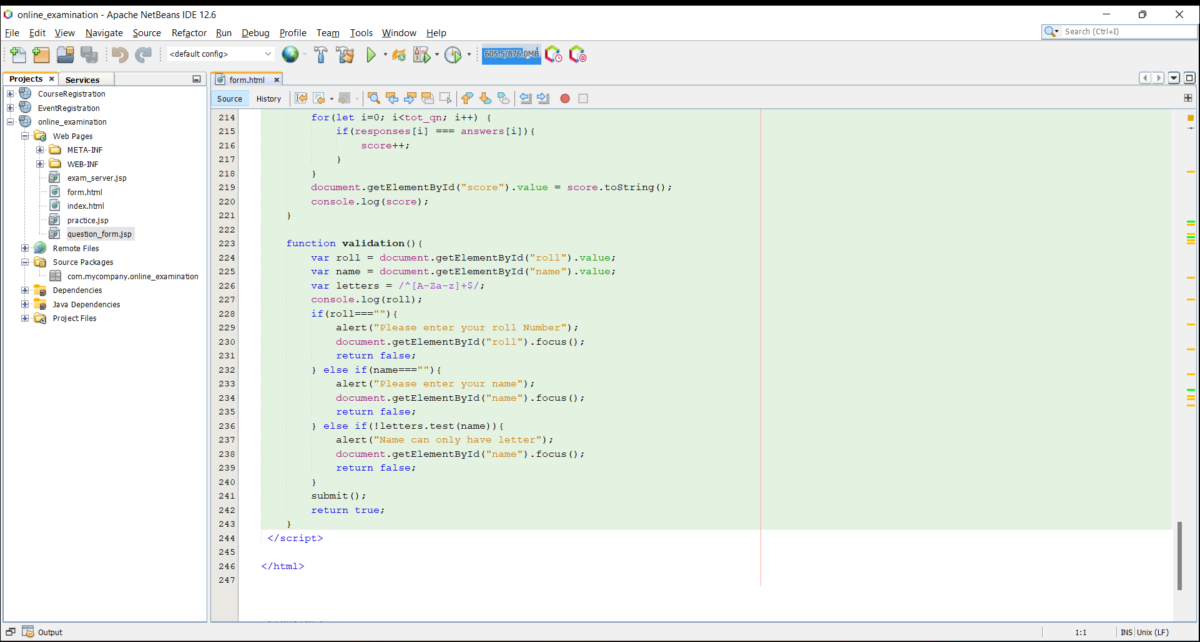

Exam Server(displays Marklist) JSP:

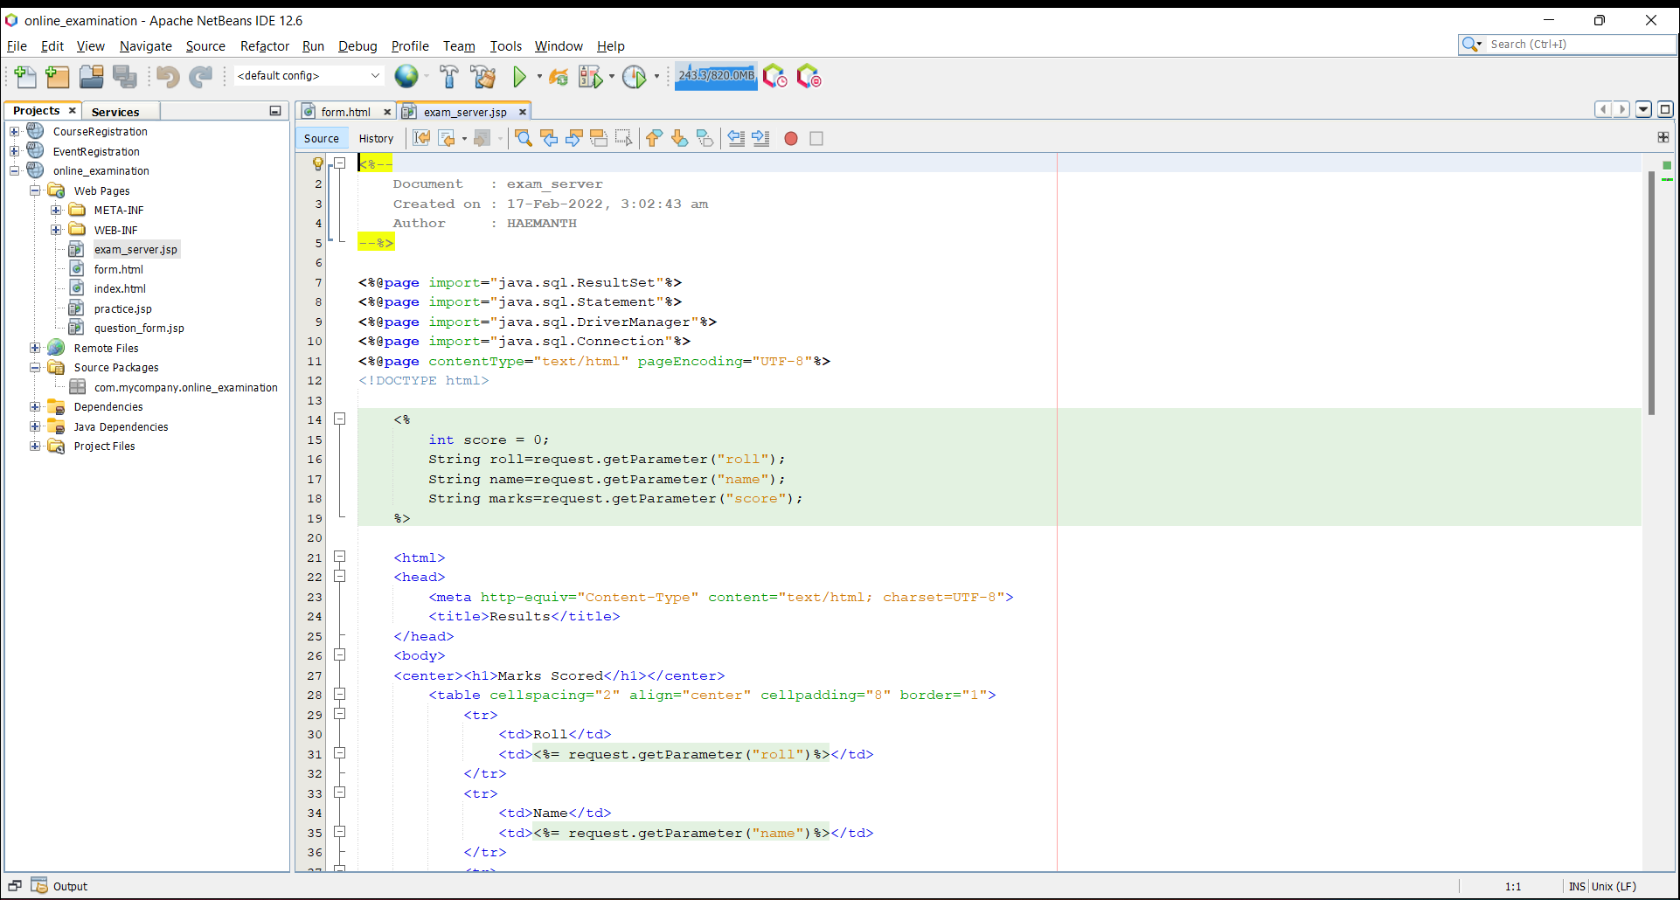

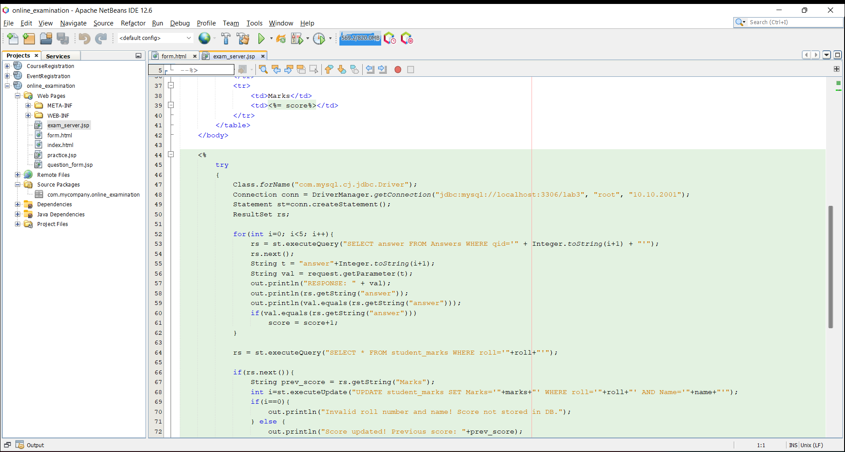

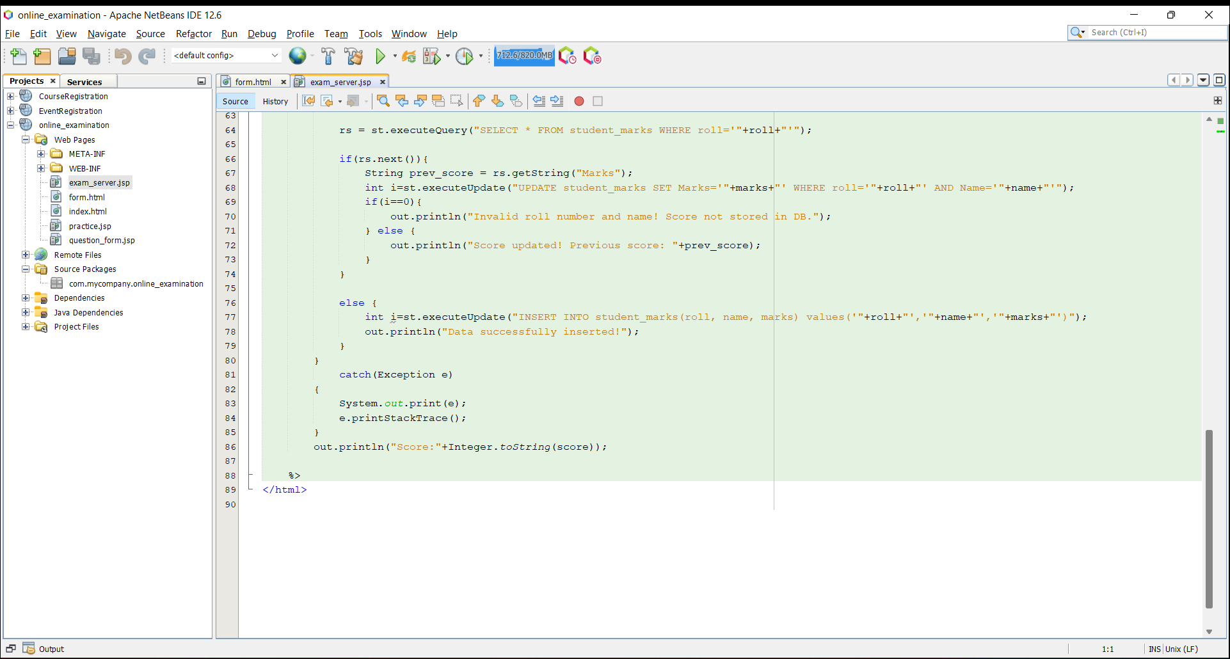

Screenshots of application:

Database structure:

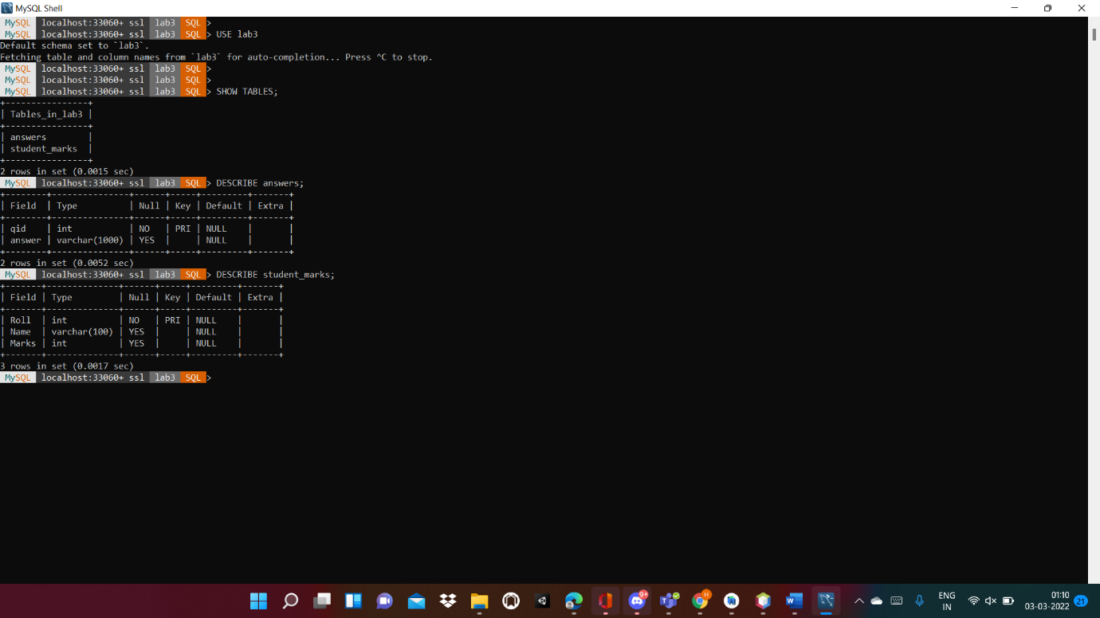

Answers Table:

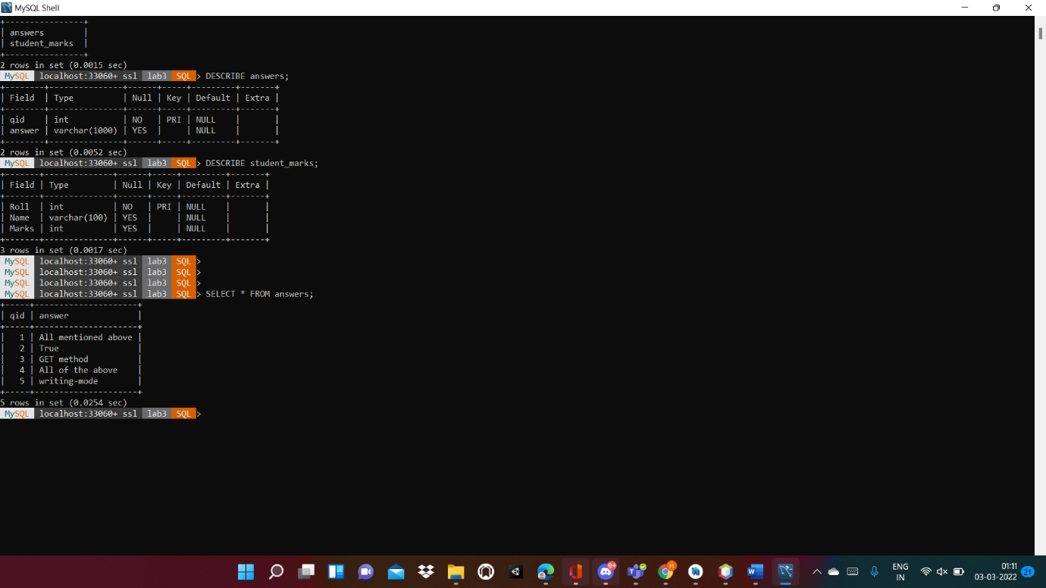

Students Table:

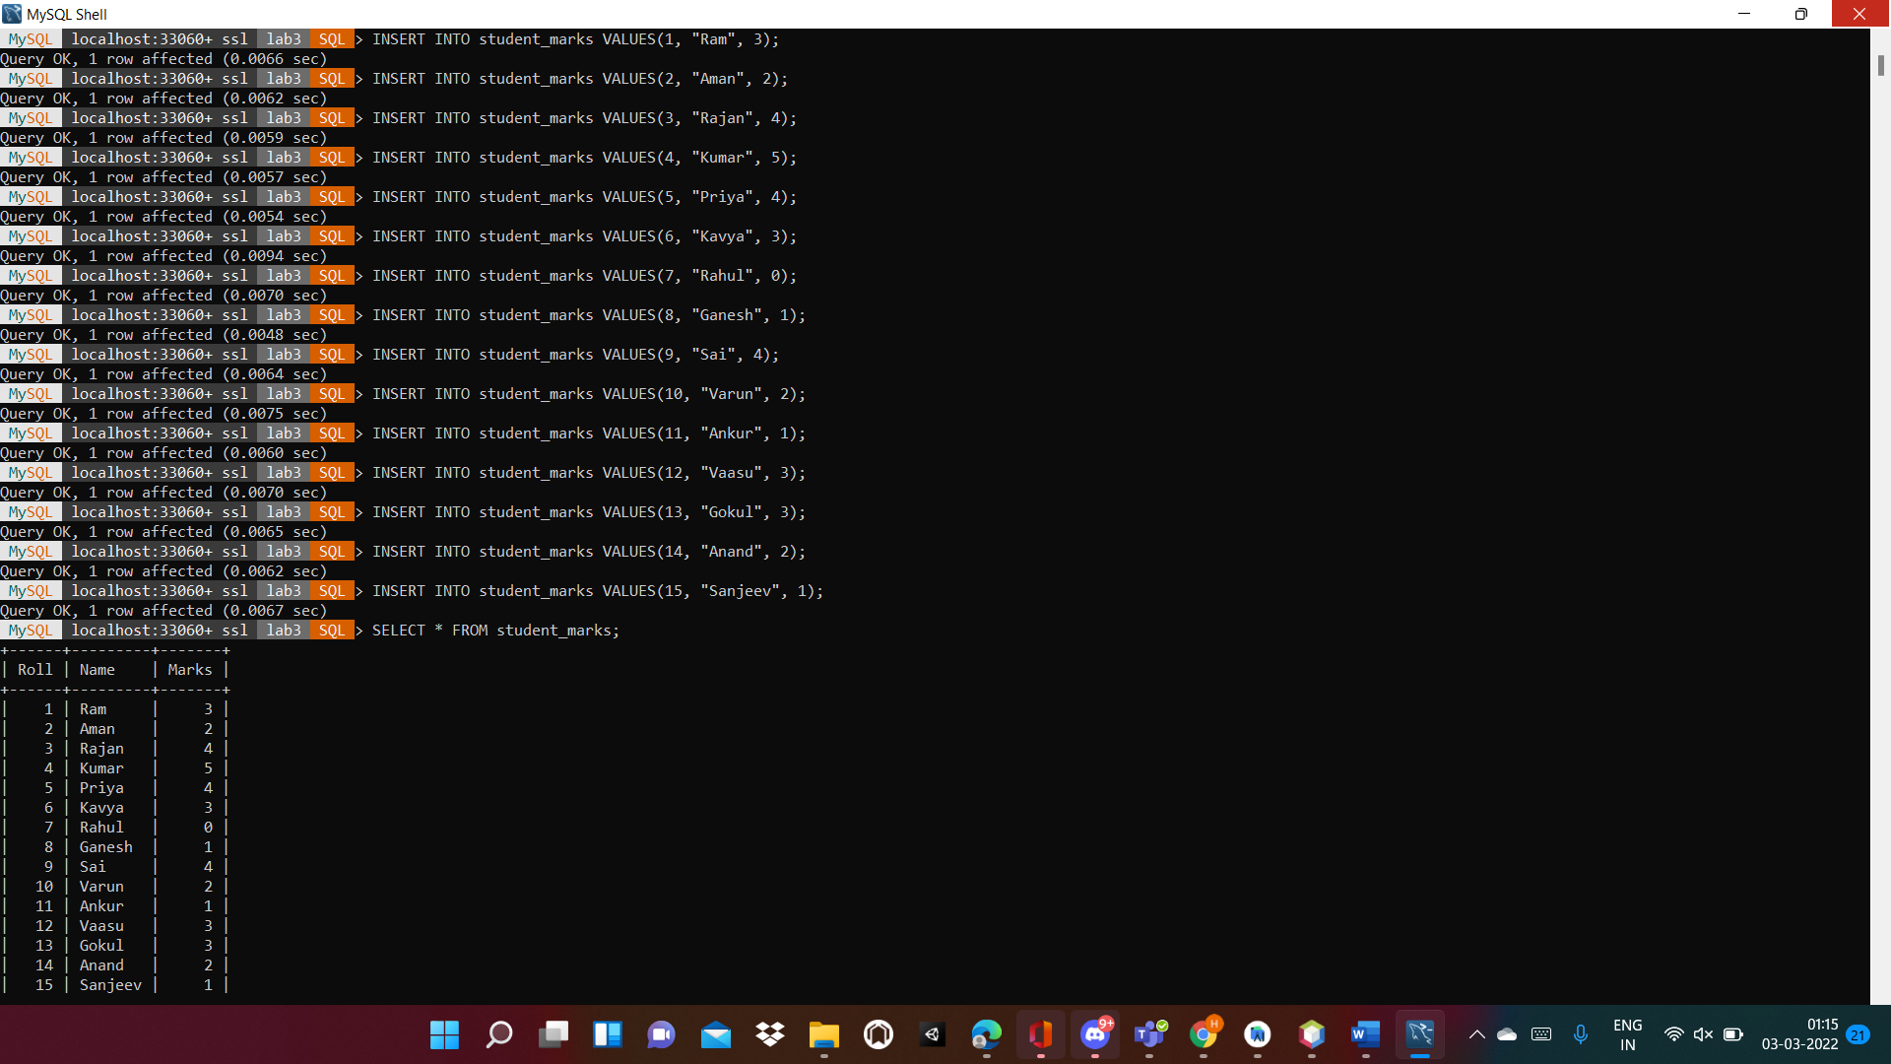

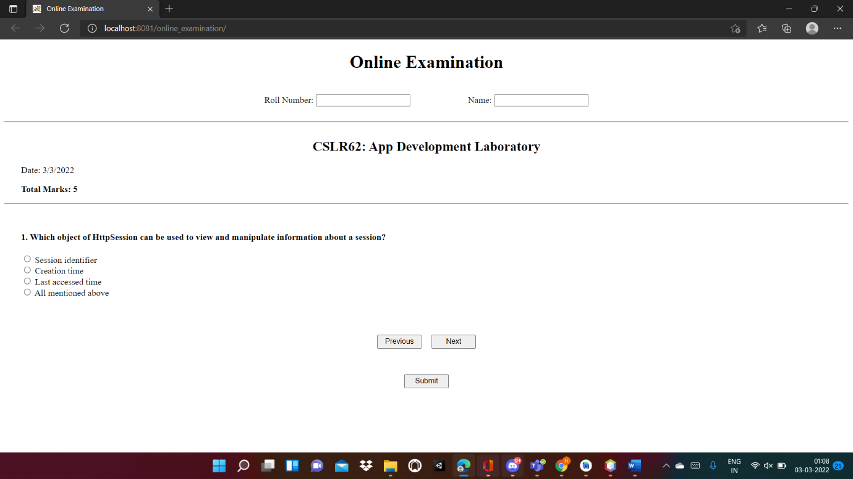

Clicking previous from first question:

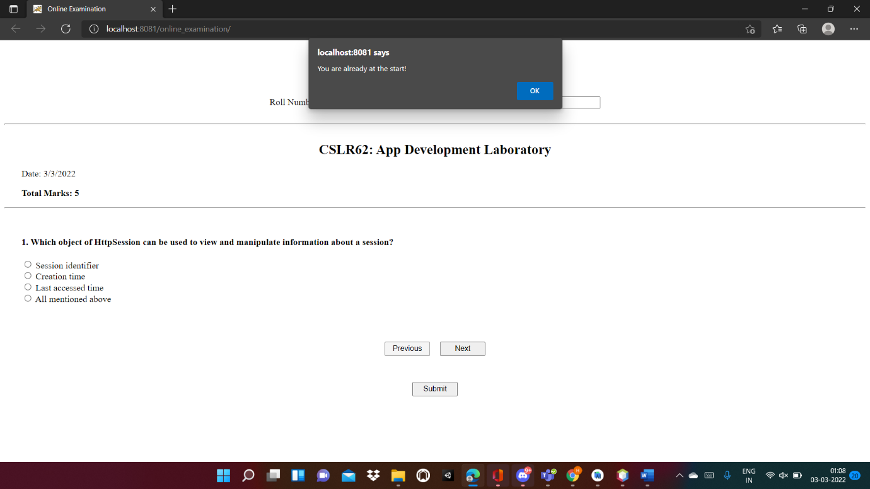

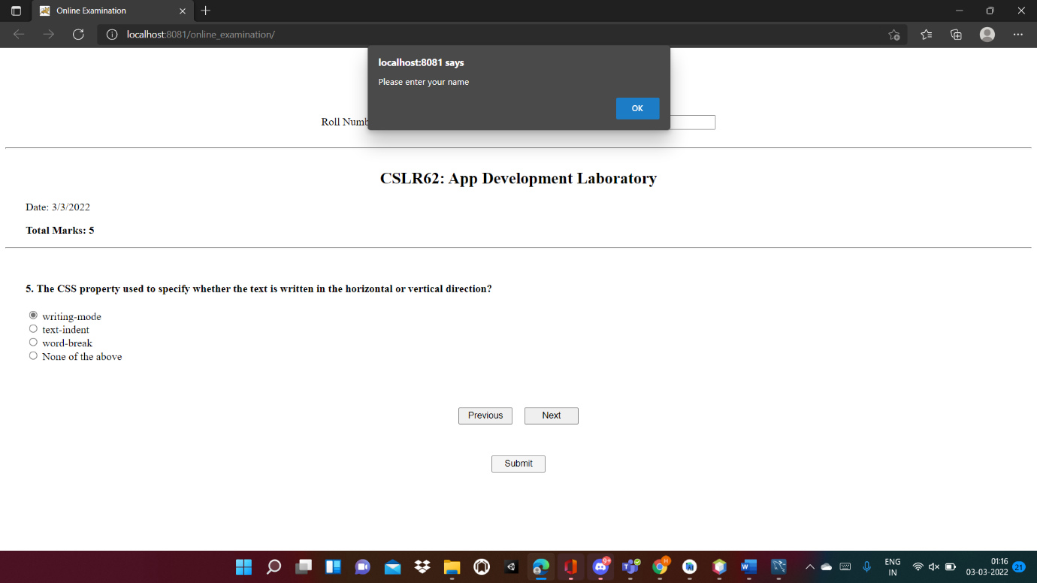

Test taken by New user:

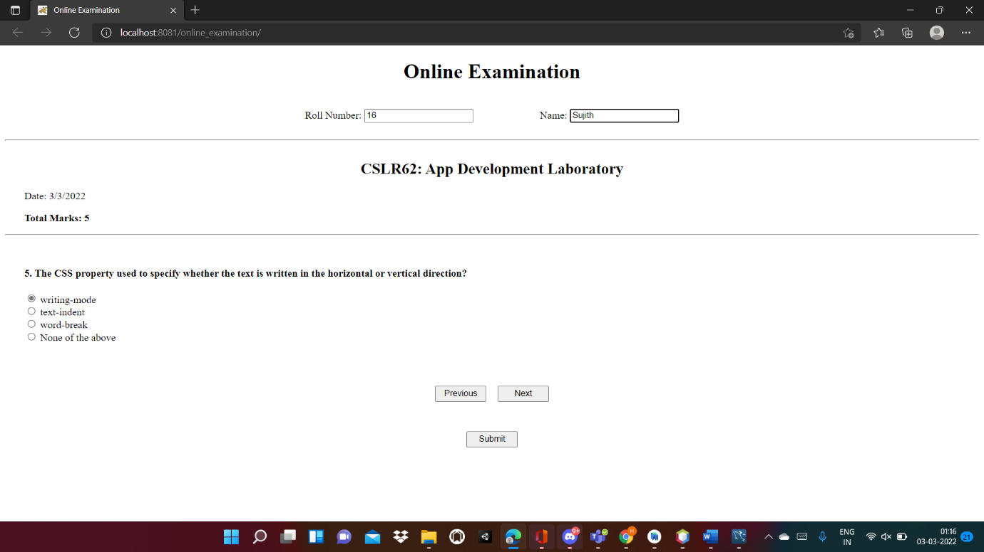

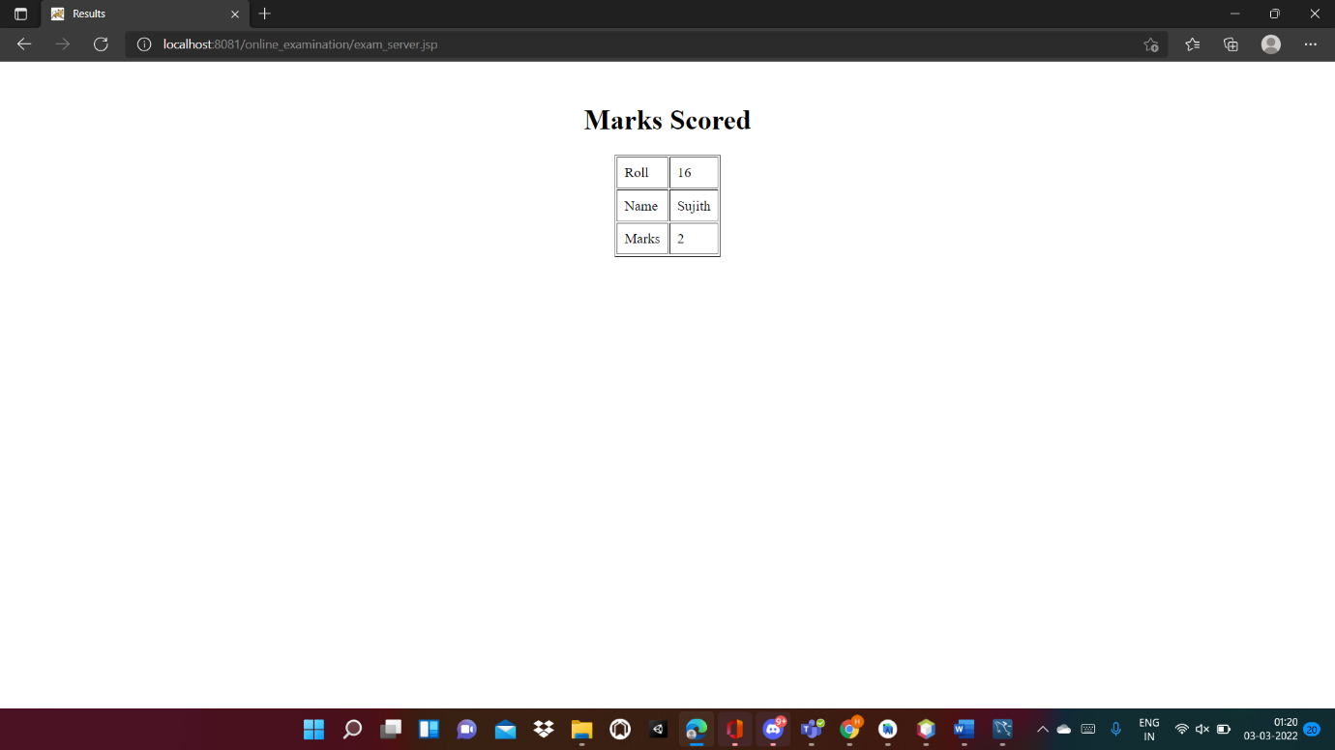

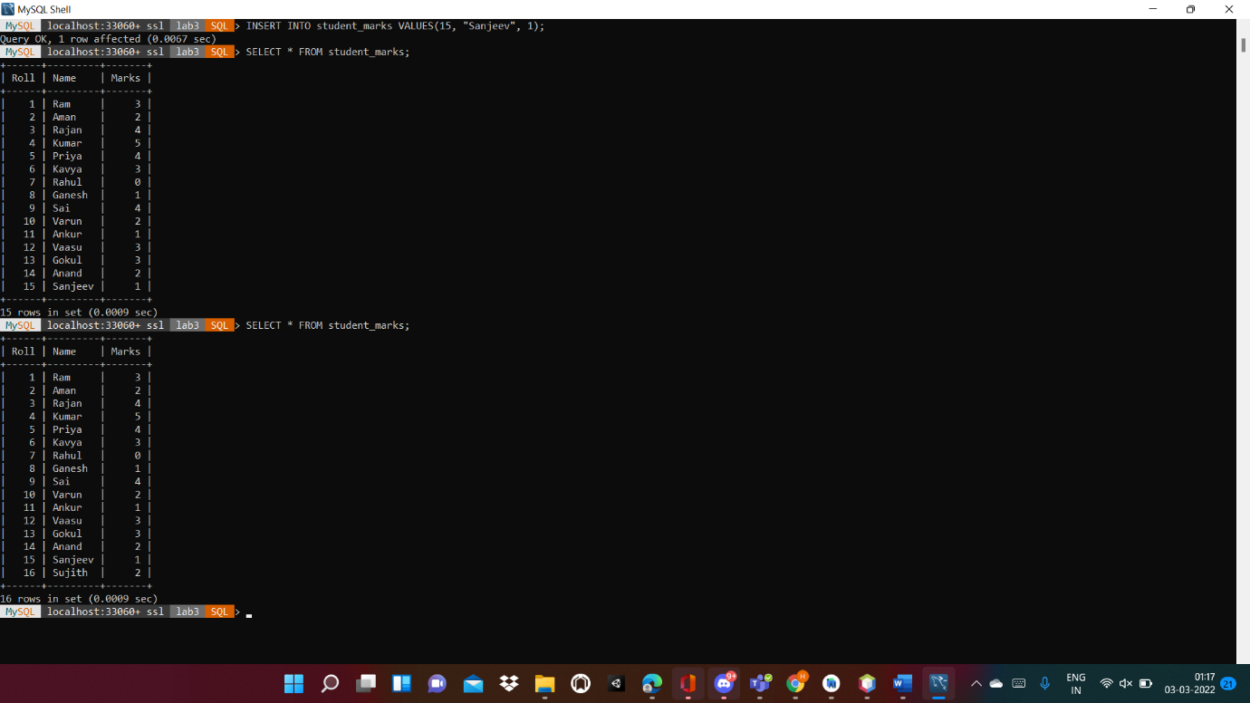

Test taken by existing user:

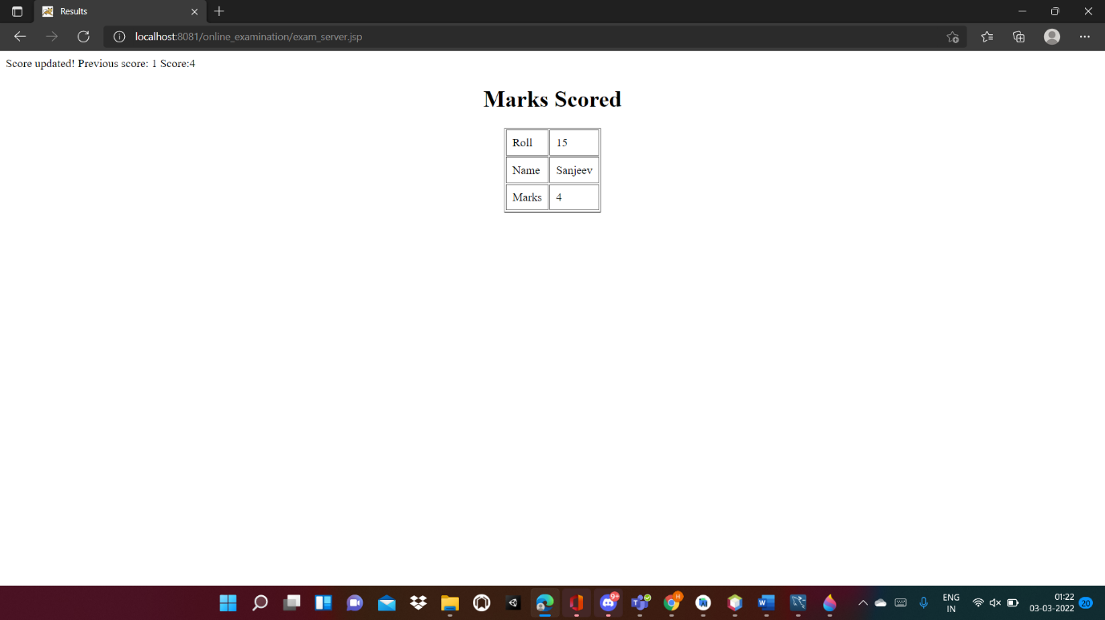

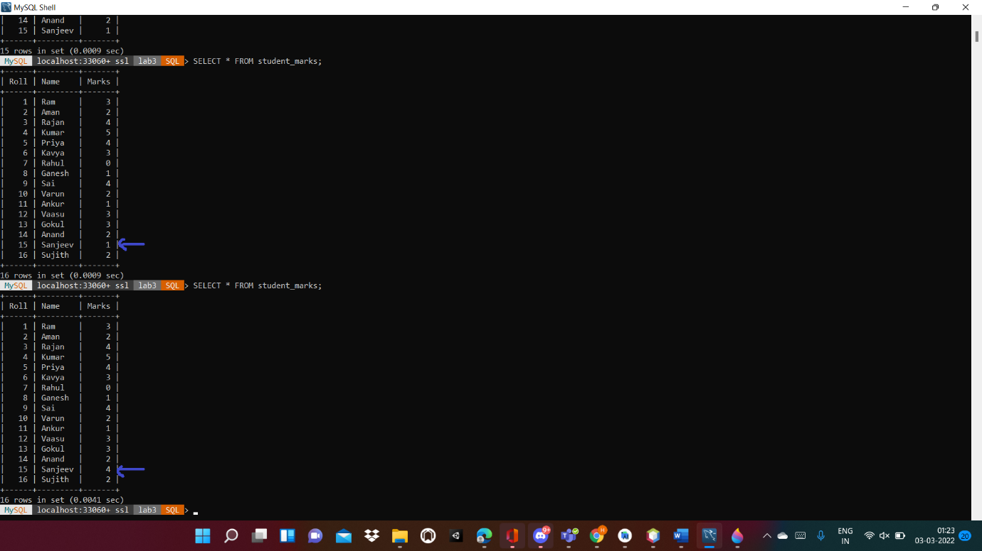

Test taken by existing user but gives wrong name/roll number:

